INTRODUCTION

1.1 OVERVIEW

DESIGN A SOCIALMEDIA POST USING IN THE CANVA

THAT WAS VERY EASY TO USE ANY ONE TO USE THIS CANVA EASIER

1.2 PURPOSE

MY PROJECT IS CREATING A SOCIAL MEDIA POST

I CREATE A SOCIAL MEDIA POST IN THIS CANVA

2 PROBLEMS DEFINITION AND DESIGN THINKING

2.1 EMPATHY MAP

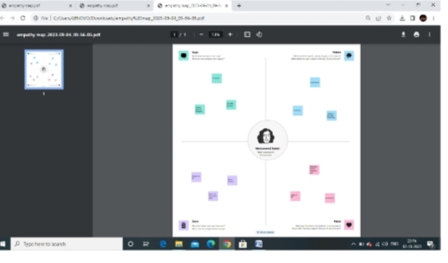

2.2 BRAINSTORM AND IDEA PRORITIZAPION

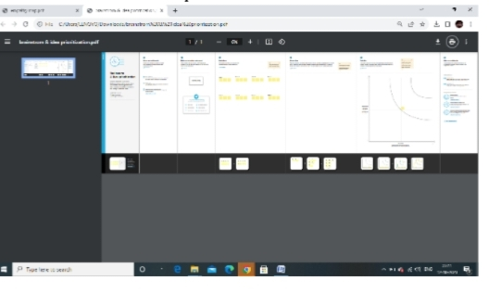

3 RESULT

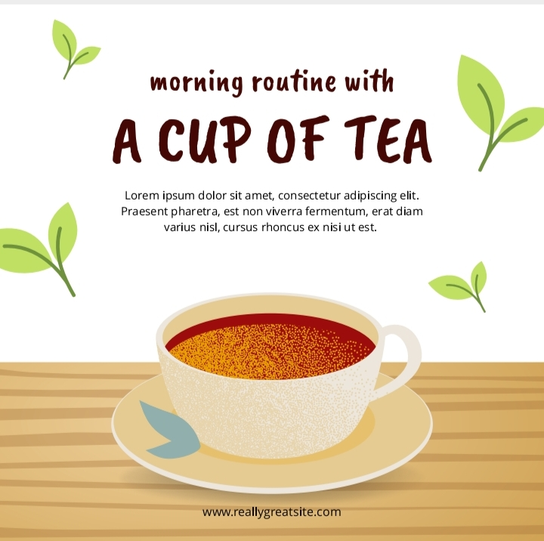

4 ADVANTAGES AND DISADVANTAGES

* EASY TO USING THIS CANVA
* FRESHERS CAN EASY TO DESIGN ANYTHING IN THIS CANVA
* IN THIS CANVA HAS MANY TEMPLATES
* CANVA HAS VERY USEFUL TO EVERYONE

5 CONCLUSION

EASILY FINISH MY PREOJECT SOCIAL MEDIA POST . CANVA IS THE MOSTUSEFUL AND BEST APP FOR THE FRESHERS . BECAUSE THAT HAS MANY TEMPLATES THAT WAS EASY TO USE .